Assignment 8

Consider the multi way search tree of Lecture 8, slide 39. Why isn’t it a valid (2,4) tree? Justify your answer. What could we do to make it into a valid (2,4) tree? Draw the valid (2,4) tree.

Answer: external nodes of the node 30 have different depth 3, others have depth 2.

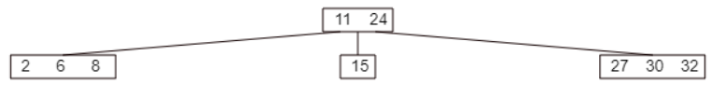

R-3.10 A certain Professor Amongus claims that a (2,4) tree storing a set of items will always have the same structure, regardless of the order in which the items are inserted. Show that Professor Amongus is wrong.

Answer: if storing the list 5, 8, 3, 9, 2, 7, 1, 4, 6, the tree is as below:



If the following tree is built from the list above but with reserved order, 6, 4, 1, 7, 2, 9, 3, 8, 5

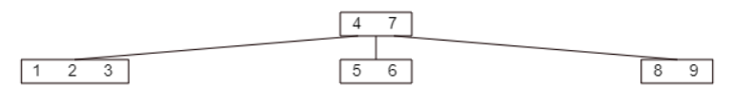

As we see, 2 trees have different structures.

A. Insert the following sequence of keys into an initially empty 2-4 tree in this order: (16, 5, 22, 45, 2, 10, 18, 30, 50, 12, 1, 33)

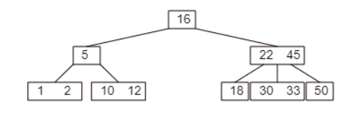

Use the following URL to check at each insertion in A above. http://cs.armstrong.edu/liang/animation/web/24Tree.html

C-4.11 Suppose we are given an n-element sequence S such that each element in S represents a different vote in an election, where each vote is given as an integer representing the ID of the chosen candidate. Suppose we know who the candidates are and the number of candidates running is k < n. Describe an O(n log k)-time algorithm for determining who wins the election.

|  |  |
| --- | --- |
| Algorithm findWinner(S, C)  B <- new Dictionary(BST)  cnt <- 0  for each id in C do  B.insertItem(id, cnt)    maxVote <- 0  winnerID <- 0  v <- 0  for i<-0 to S.size()-1 do  v <- S.elementAtRank(i) //return candidate ID at the sequence i  p <- B.findElement(v)    if p <> NO_SUCH_KEY then  cnt <- B.elem(p) + 1  B.insertElement(B.key(p), cnt)  if cnt > max then  max <- cnt  winnerID <- B.key(p)  return winnerID | O(1)  O(1)  O(k)  O(k)  O(1)  O(1)  O(1)  O(n)  O(n)  O(n log k)  O(n)  O(n)  O(n log k)  O(n)  O(n)  O(n)  O(1)  Total running time: O(n log k) |

C-4-22 Let A and B be two sequences of n integers each. Given an integer x, describe an O(n log n)-time pseudo code algorithm for determining if there is an integer a in A and an integer b in B such that x = a + b.

|  |  |
| --- | --- |
| Algorithm findPair(A, B, x)  Input: n-element sequence A and B include n integers  Ouput: true if existing a pair a & b so that a + b = x    B <- new Dictionary(HT)  for each n in B do  B.insertItem(n, n)    for each a in A.elements() do  b <- B.findElement(x - a)    if b <> NO_SUCH_KEY then  return true  }    return false | O(1)  O(n)  O(n)  O(n)  O(n logn)  O(n)  O(1)  O(1)  Total running time: O(n logn) |